Unit Environmental Cost for Electricity–Grid

<https://www.eia.gov/electricity/state/newjersey/>

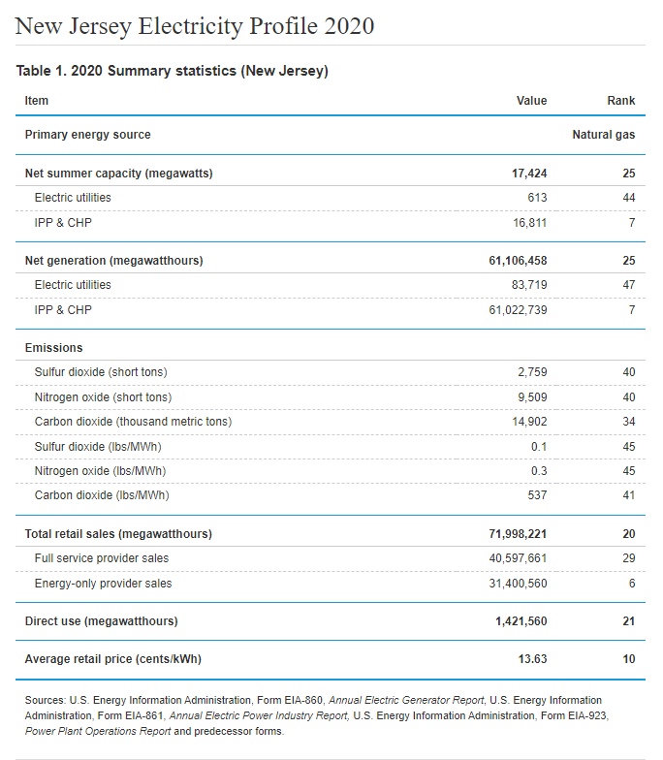

Conversion between SO2 and CO2

Conversion between NO and CO2

$\frac{626.4 lbs}{mWh}*\frac{1 mWh}{1000 kWh}*\frac{1 metric ton}{2204.62 lbs}*\frac{\$600}{1 metric ton}=\$0.17/kWh$